Please complete form & return to airport manager at manager@flycgra.com

Fees are $450.00/day for private groups and $225.00/day for governmental agencies. Request must be accompanied by a Certificate of Liability Insurance, listing The City of The Dalles as an additional insured. Insurance Limits shall be $1,000,000 per incident, $2,000,000 aggregate minimum. Failure to provide insurance certificate will result in denial of request.
- Date submitted:

- Sponsor Hosting Event: Primary Contact Name: Email: Phone: Mailing Address: _

- Are you a public agency? Yes No

- Description of Event:

- Date(s) of Event:

- Duration of Event: From am / pm To: am/pm

- Estimated attendance:

- Estimated number of staff working the event:

- Estimated number of guest vehicles:

- Does the applicant plan to invite any media personnel to the event? Yes _ No
  - If yes, please coordinate with airport manager

- Will additional equipment be brought onto the facility? Yes No
  - If yes, please list items below and include on site layout plan:

- (Private / Non-governmental agencies) I understand a copy of insurance will be provided with this application. Initials

- I understand my event may be rescheduled/cancelled at short notice and at no expense to CGRA in the event of fire support operations taking place at the facility. Initials

SITE LAYOUT PLAN (Please provide basic diagram of event layout plan i.e. parking, staging area, course, etc. For the safety of airport operations and airport tenant’s areas denoted in red are not available for lease and requestor is prohibited from entering designated areas during event.)

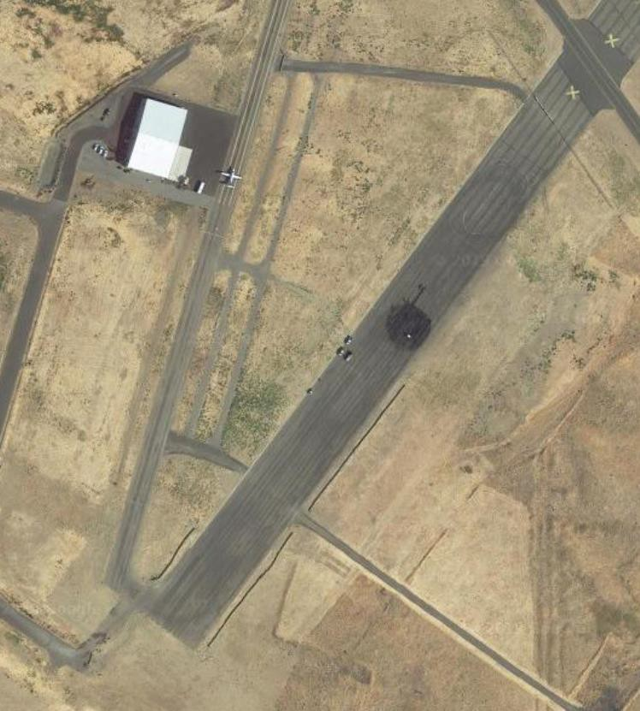

Signature: Date:
Airport Manager: Date:

